Warsaw, 30th January 2018

Long-term car rental grew by 13.1% in 2017 - the highest increase in the last 6 years
The industry was growing faster than other forms of financing of company cars

In 2017, the long-term car rental industry in Poland recorded the highest growth rate in the last 6 years, reaching 13.1% y/y. This is the result of the dynamically growing interest in long-term rental among entrepreneurs, especially from the SME sector, which has been growing for several years. As a result, in the previous year the industry grew in terms of an increase in the number of registered new cars faster when compared to other forms of company car financing, i.e. purchase, credit and traditional financial lease.
Every fifth new car purchased by entrepreneurs in our country was bought for the purpose of long-term rental. The industry purchased in Polish showrooms 22.8% more cars than a year before and by nearly half more than 2 years ago. Excellent results were also reported last year by the car rental industry, which achieved a growth rate of 33.2% y/y.
2017 was the second very successful year in a row for the entire automotive market in Poland. Sales of new passenger cars reached the highest level in this century. 486,000 cars left the showrooms, an increase of 17%, which is over 70,000 more than a year ago. Such good results have not been recorded in the market of new cars in our country since 1999. The prosperity, as in the last few years, is mainly caused by the companies - they were the buyers of nearly 70% of all new passenger cars sold in the past year. Comparing to 2016, the role of institutional clients was even greater - the share of entrepreneurs in car sales increased by 2%. Moreover, it is the purchases of companies that the automotive market owes to the higher level of sales achieved in the past year – by 70,000 more passenger cars sold, the vast majority, as much as 81.5% (over 57,000) were acquired by entrepreneurs (in 2/3 by leasing companies, Rent-a-Car and CFM, i.e. long-term rental). To put it simply, the increase in sales of new cars in Poland in 2017 was almost entirely generated by companies.
The sales of new passenger cars y/y that was 70,000 higher in 2017, was mainly
caused by companies
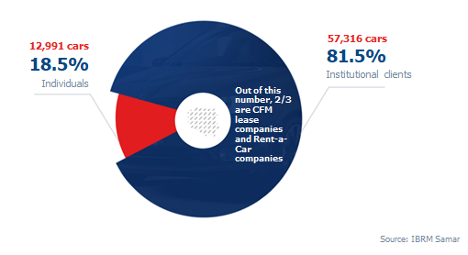

The number of new cars provided under a long-term rental arrangement grew faster than in the case of financial lease, car purchase and loans in total
In Poland, during 2017, companies purchased a total of 339,000 new passenger cars. Each fifth of them (19.6%) was in long-term rental, i.e. 66,300 cars, of which the vast majority, nearly 52,000, were acquired by companies belonging to PZWLP.

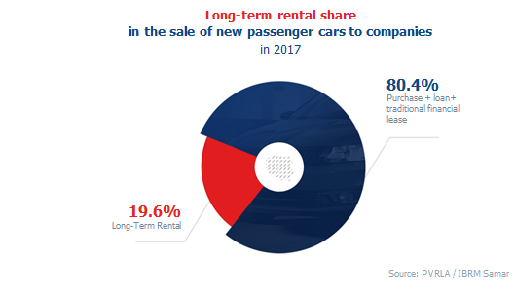
The long-term rental industry purchased 22.8% more new passenger cars than a year ago and therefore developed in terms of the number of registered vehicles faster than other forms of company cars financing. Taking into account the purchase using own funds, loans and traditional financial lease, last year companies acquired 19.8% more cars.

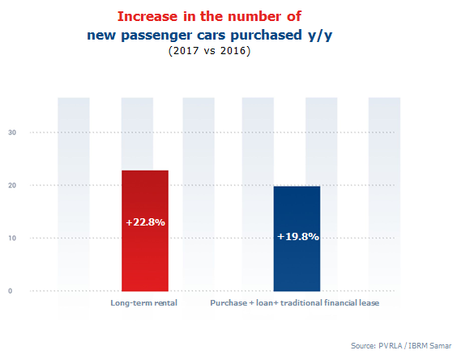
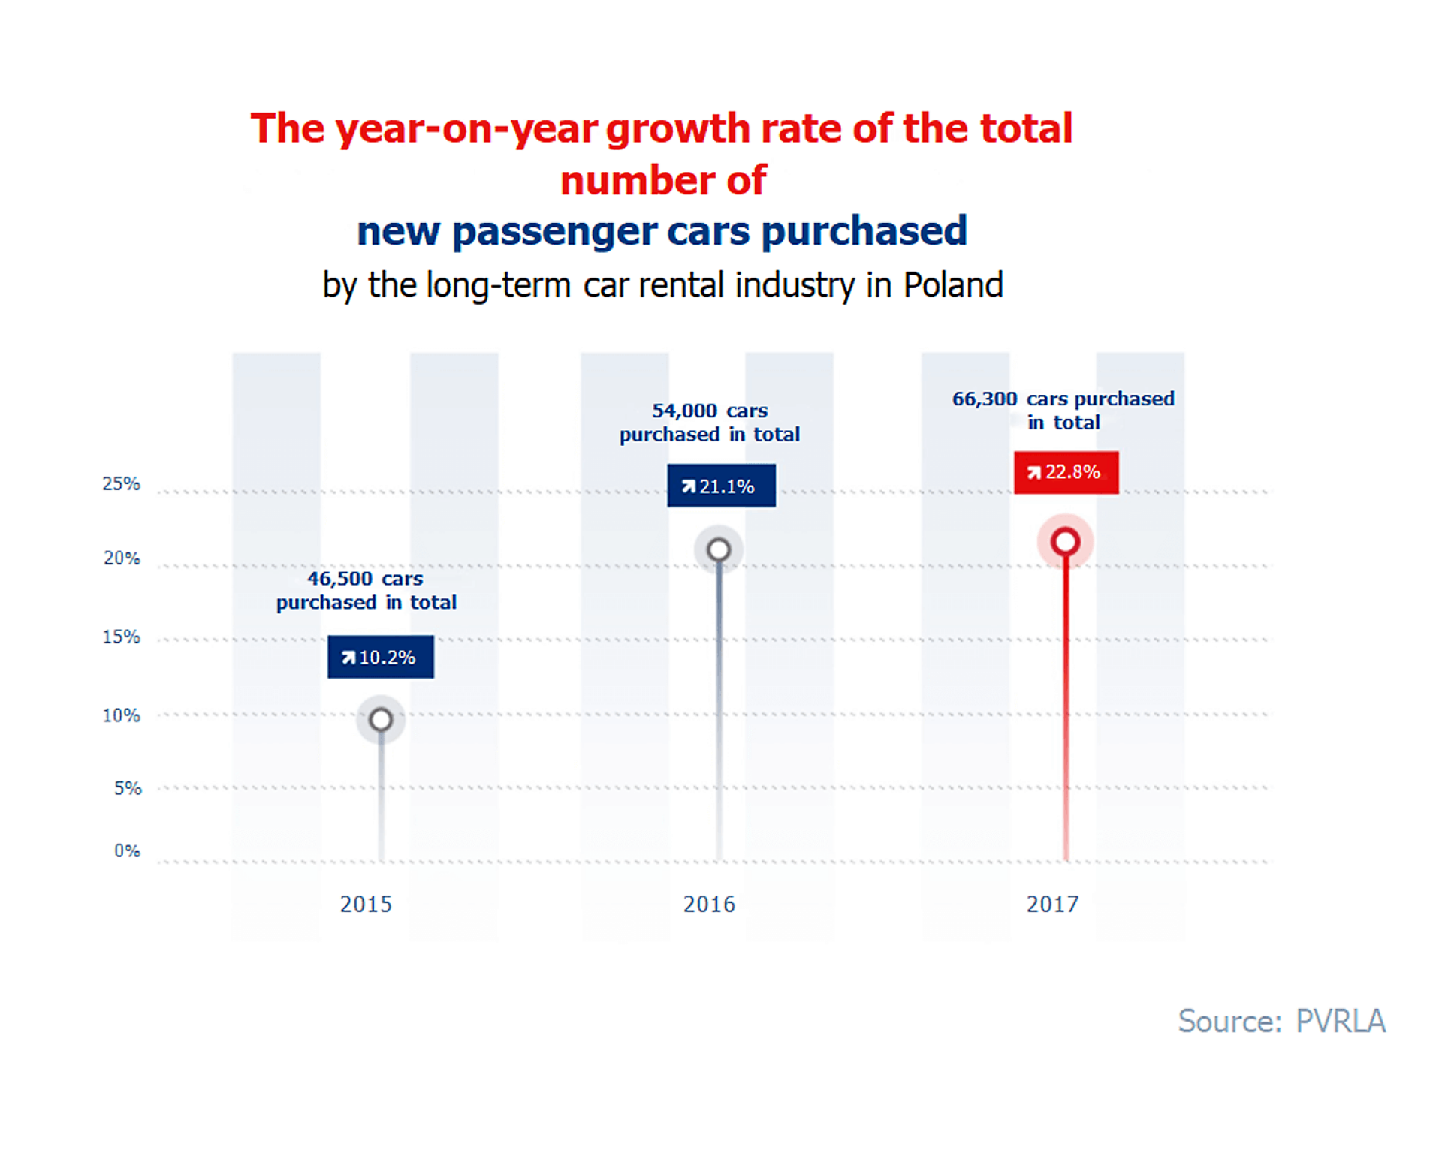
The trend of the growing popularity of long-term car rental among entrepreneurs
13.1% y/y, i.e. the growth dynamics of long-term car rental achieved in 2017, is the best result recorded by the industry in the last 6 years. The growth rate of the industry has been developing continuously since 2014, which, according to experts, clearly indicates the market trend.
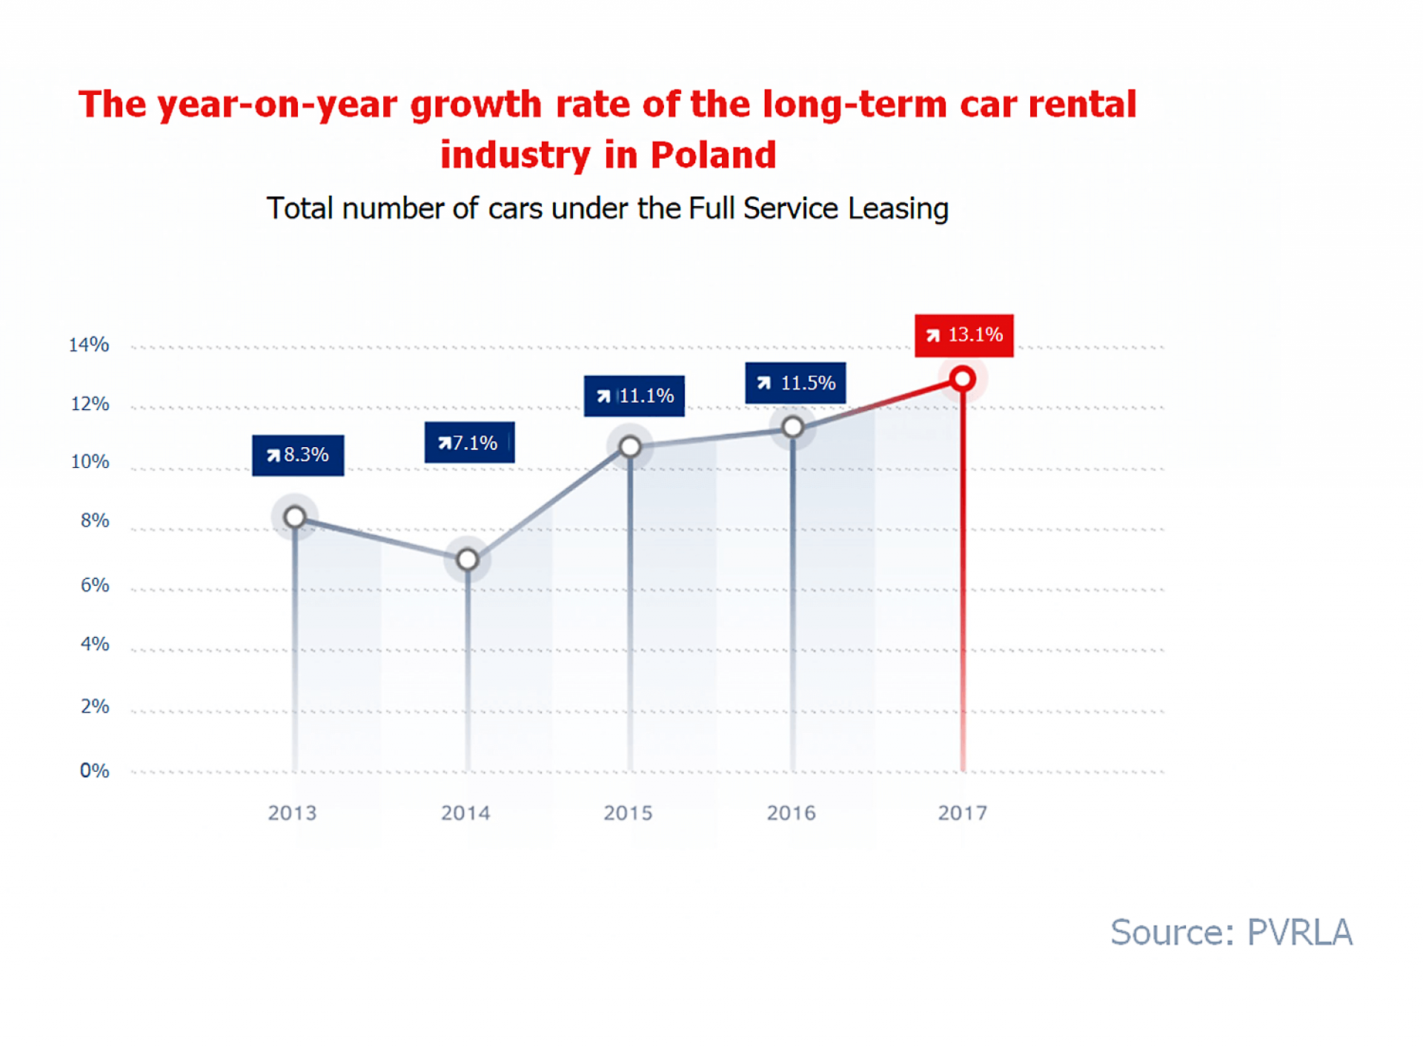
The growth rate of long-term car rental in Poland, which has been increasing for several years, combined with the number of new cars registered by the car industry growing faster than other vehicles indicates that we are dealing with the market trend of increasing popularity of long-term rental – says Sławomir Wontrucki, President of the Management Board PVRLA, President of LeasePlan Polska.. – The industry is increasingly driven by new customers from the SME sector. In the coming years, their impact on the growth of the CFM market will be even greater. Small and medium entrepreneurs become more convinced to fully outsource business cars, and thus long-term rentals. The ongoing change in the preferences and philosophy of entrepreneurs in Poland regarding company cars is also responsible for the growing dynamics of the industry. They are evolving from the model of having fleet cars, and therefore financing them through purchase or loans, to the model of use. Currently, the vast majority of cars purchased by companies are already provided under some form of a leasing arrangement – traditional financial lease, operating lease or operating lease with service, i.e. under a long-term rental arrangement. According to the experience of more developed Western European markets that already have this transformation behind them, moving away from buying or borrowing, companies usually choose leasing in the simplest form, that is, traditional financial lease Then they decide to opt for the so-called long-term rental, and therefore full outsourcing in terms of not only financing, but also service of the fleet. We expect that some entrepreneurs in Poland that currently use traditional financial lease will at some point change it into long-term rental. Then the industry may receive a strong, further development impulse.
The total fleet of long-term rental companies belonging to PVRLA exceeded at the end of 2017 the symbolic barrier of 150,000 vehicles and had almost 152,000 cars (excluding the Athlon Car Lease fleet). 85% of cars were provided under a full service leasing arrangement, which is one of the two long-term rental services guaranteeing full car service, while 15% of vehicles were provided under a leasing and service arrangement, providing the entrepreneur with partial car service. Among the most popular car models in the total fleet of PVRLA companies in long-term rental were: Skoda Octavia, Ford Focus, Toyota Yaris, Skoda Fabia, as well as Volkswagen Passat.
The diesel’s share is the largest, but it is falling - more and more petrol and ecological cars
By the end of previous year, Diesel remained the dominant drive in cars used for long-term rental, accounting for 2/3 (66.3%) of all vehicles. However, for several quarters, the downward trend in the share of cars with diesel engines has been noticeable. Throughout 2017, the share of Diesel decreased by 4.5%. On the other hand, the popularity of cars powered by petrol engines grew, which share in the total fleet amounted to 32.7% at the end of 2017 and increased by 3.8% in the previous year. Eco-friendly cars, which are driven by hybrid and electric engines, were still relatively rare - their share amounted to 1%. However, it is worth to mention the growth rate of the share of cars with environmental engines, that - in 2017 - has more than tripled. In total, at the end of December, in the fleet of PVRLA companies, 1566 ecological cars were considered as long-term rentals - 1542 hybrids (an increase from 382 vehicles of this type at the end of 2016) and 24 electric cars.
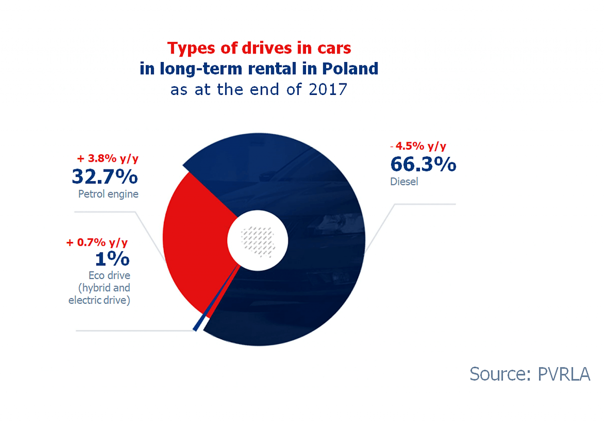
The vehicles purchased by PVRLA companies for the needs of long-term rental were more environmentally friendly when it comes to carbon dioxide emissions. As for the passenger cars purchased in the fourth quarter. of 2017, the average CO2 emission amounted to 123.9 g/km and was by 4.5% (5.8 g/km) lower than in the corresponding period of the previous year. As far as delivery cars are concerned, the average CO2 emissions of vehicles purchased in the last quarter of the previous year amounted to 149 g/km and were 5.9% (9.3 g/km) lower than in the comparable time of 2016.
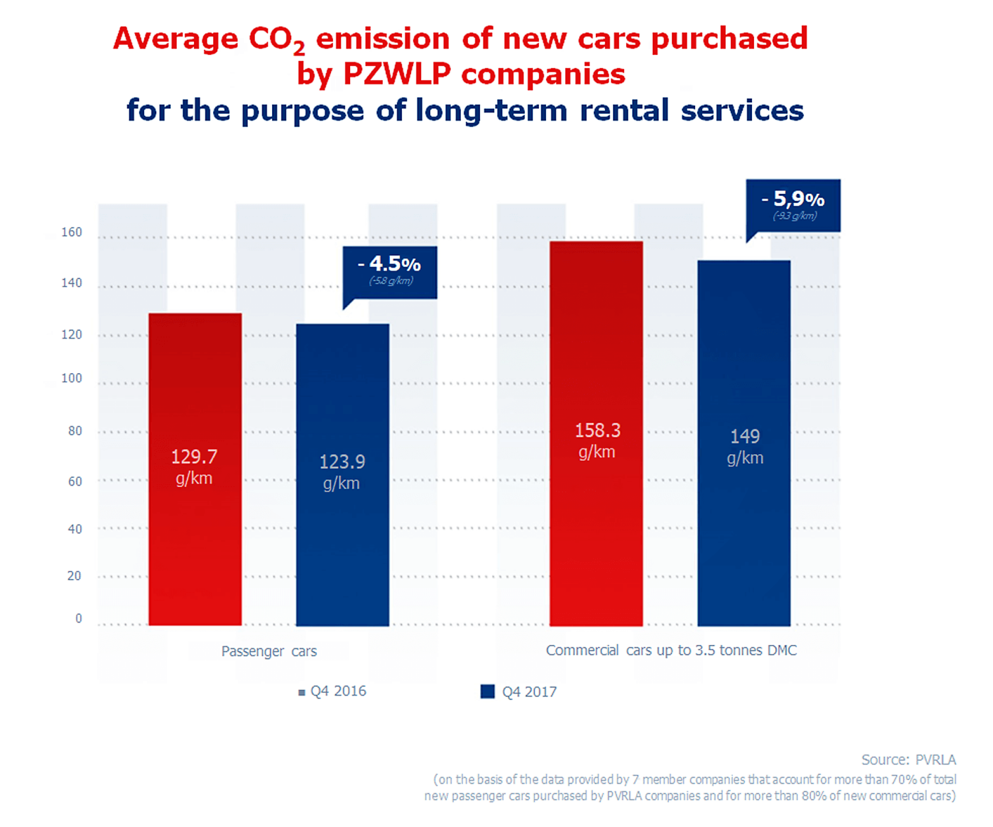
The car rental industry in the 2017 - an increase of as much as 33.2% y/y
2017 was also very successful year for the car rental industry, represented in PVRLA by 7 large networked, Polish and international car rental companies. By the end of December, the total fleet of Rent-a-Car companies in PVRLA (excluding Avis Budget / Jupol - Car Sp. z o. o.) in short-term rental services (1-30 days) and medium-term rental (1 month - 2 years) amounted to over 15,000 cars (15,068), which means that the industry recorded an increase of 33.2% y/y.
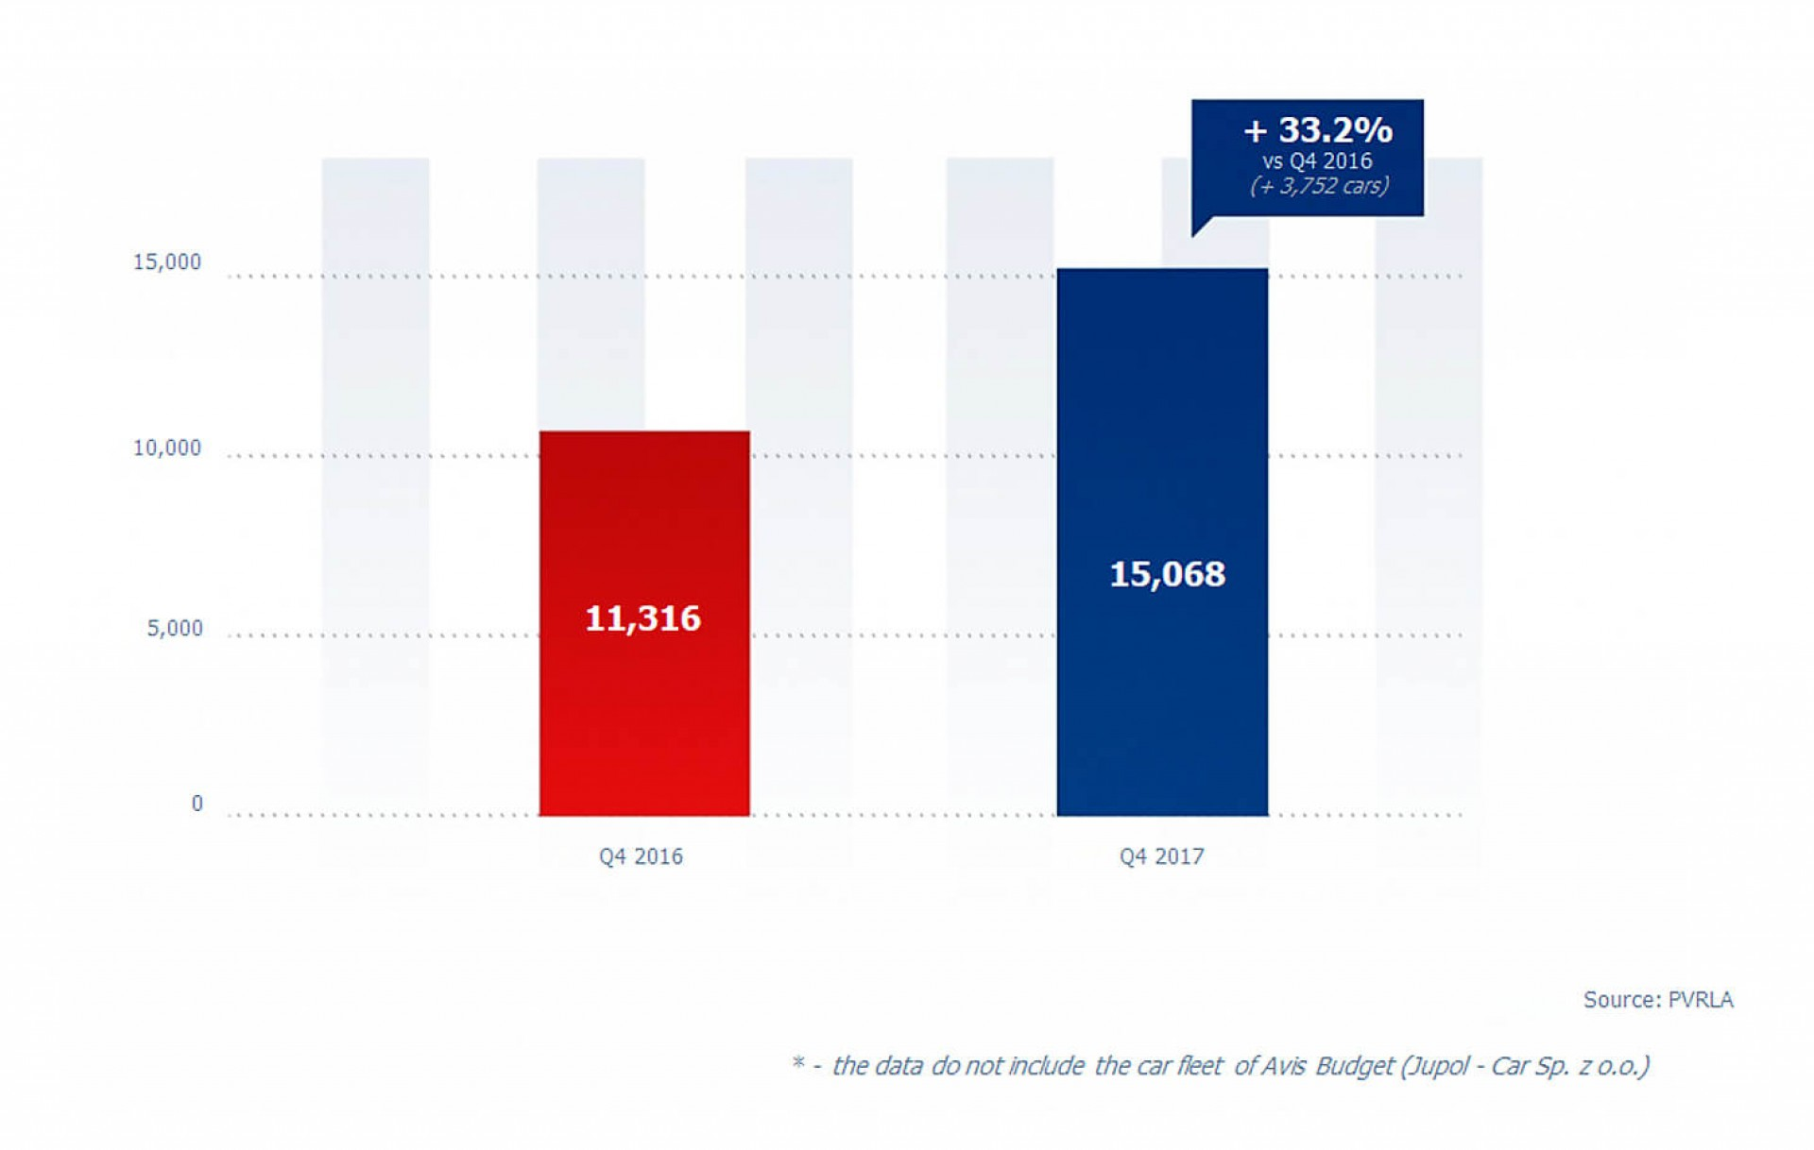
Stability of regulations important for the development of the fleet industry in 2017
Very good results recorded in 2017 by the entire fleet market in Poland, including the long-term rental industry, according to PVRLA experts, were, besides many other factors, possible to achieve also thanks to regulations that have been stable for several years.
The growing purchases of company cars made by entrepreneurs are largely supported by stable regulations, including tax regulations – says Leszek Pomorski, PVRLA Member of the Board, President of Alphabet Polska Fleet Management. – It is expected to remain unchanged in 2018 as well. This year, one of the most important and long-awaited by the fleet industry regulation will be the Electromobility Act, which, if it introduces tax exemptions and facilitations for entrepreneurs purchasing hybrid and electric cars planned at the stage of the draft, can have a positive impact on the growth of the number of ecological cars in fleets.
The most important events in the fleet industry in 2017 include launching at the Faculty of Transport of the Warsaw University of Technology, the first in Poland, full-size and extensive programmable fleet postgraduate studies “Car fleet management and mobility” in October. The study programme emphasizes the practical knowledge needed in the fleet market and was co-created by experts from PVRLA and SKFS (Association of Fleet Managers). Experts from both organizations also constitute over half of the lecturers conducting classes at the university.
In addition, in 2017, during the 10th PVRLA Awards Ceremony, for the first time the organization awarded its prize to a car dealer. The new category of PVRLA Award was introduced in response to the increasingly important role of the fleet industry for the condition of the automotive market in Poland and underlines the importance of good relations and cooperation of fleet companies with the environment of car dealers.
PVRLA companies bought a total of over 114,000 new passenger cars
Taking into account the overall activity of 20 companies belonging to the Polish Vehicle Rental and Leasing Association (PVRLA), mainly all short-, medium- and long-term car rental services, as well as car financial lease, in 2017 PVRLA companies bought a total of 114,500 new passenger cars – 14.5% more than in 2016. This means that over 1/3 (33.8%) of new passenger cars bought in 2017 by entrepreneurs in Polish showrooms were acquired by companies belonging to PVRLA *

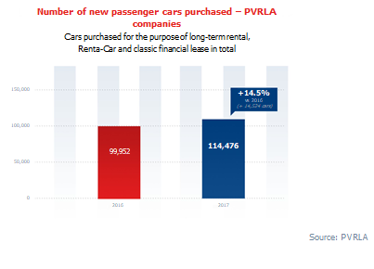
*- PKO Leasing, Volkswagen Leasing and mLeasing are also members of ZPL (Polish Leasing Association).

